Error message on entering numbers in Name, city and state
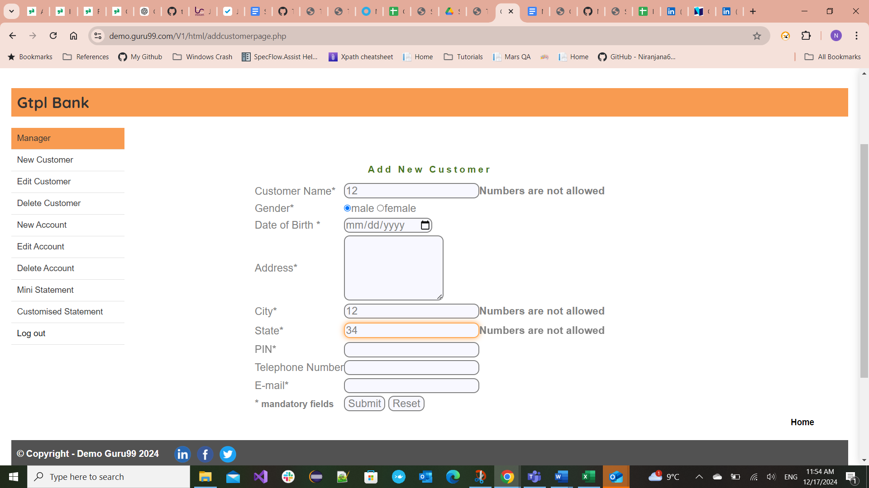
Error message on entering characters in PIN
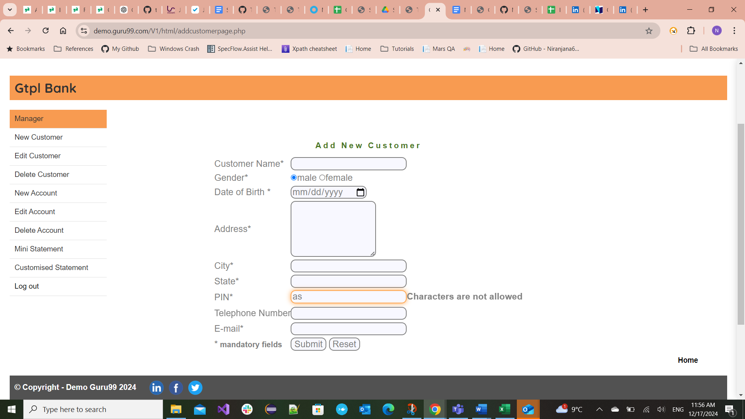

Error message on entering less than 6 numbers in PIN Code
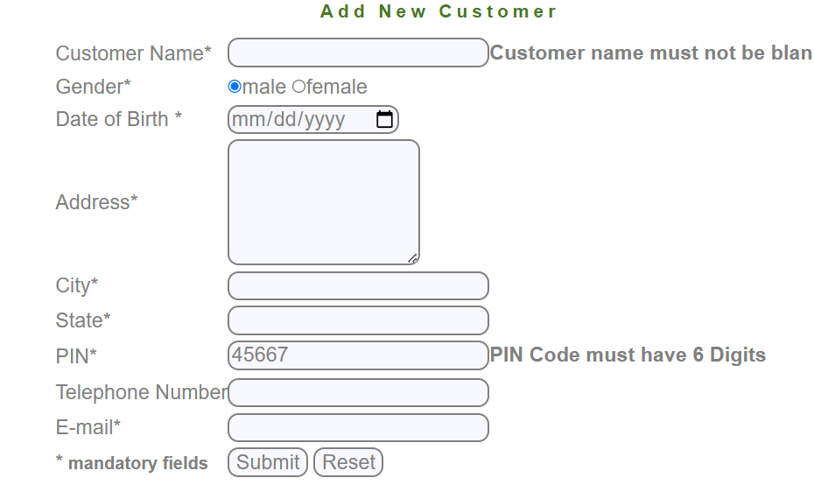

Error message on entering characters in Telephone

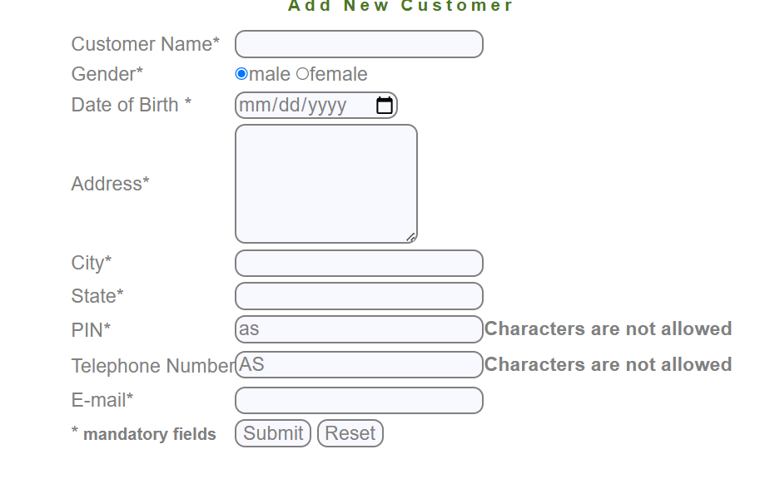

Error message on entering Invalid email id
